**Principles of Big Data Management**

**Project Phase - 1**



**Team Members:**

**Ankitha Wankhede - 16233344**

**Rajeswari Devi Namana -18135299**

**Sravya Reddy Bokka - 16240386**

***Goal:***

* To Collect Tweets using Twitter’s Streaming APIs (e.g., 100K Tweets)

([https://dev.twitter.com/docs/streaming-apis)](https://dev.twitter.com/docs/streaming-apis)

* Extract all the hashtags and URLs in the tweets
* Run the WordCount example in Apache Hadoop and Apache Spark on the extracted hashtags/URLs and collect the output and log files from Hadoop. Add a README file.

***Step 1: Collection of tweets from Twitter Streaming API:***

Executed code in python using tweepy library.

**Code Used:**

*#Import the necessary methods from tweepy library*

**from** tweepy.streaming **import** StreamListener

**from** tweepy **import** OAuthHandler

**from** tweepy **import** Stream

*#Variables that contains the user credentials to access Twitter API*

access_token = **"888958069098635264-AsvKqThYHQL02oVnfa148kEU9ooPks2"**

access_token_secret = **"rgWc4aerpJruAwdZHpjAZYHn55qD92TJnUUpaNd8G1j7I"**

consumer_key = **"zKhTdLsdjIG8HlfRa0Fhxoofo"**

consumer_secret = **"vorTGnycUlmTr6RhjocPmYJ0A3yttUTpXNBIyjB7bNw2YOSGvC"**

*#This is a basic listener that just prints received tweets to stdout.*

**class** StdOutListener(StreamListener):

**def** on_data(self, data):

**print**(data)

**return** True

**def** on_error(self, status):

**print**(status)

**if** __name__ == **'__main__'**:

*#This handles Twitter authentication and the connection to Twitter Streaming API*

l = StdOutListener()

auth = OAuthHandler(consumer_key, consumer_secret)

auth.set_access_token(access_token, access_token_secret)

stream = Stream(auth, l)

*#This line filter Twitter Streams to capture data by the keywords: 'mom'*

*#stream.filter(track=['hashtags', "(?P<url>https?://[^\s]+)"])*

stream.filter(track=[**"mom"**])

**Code Screenshots :**

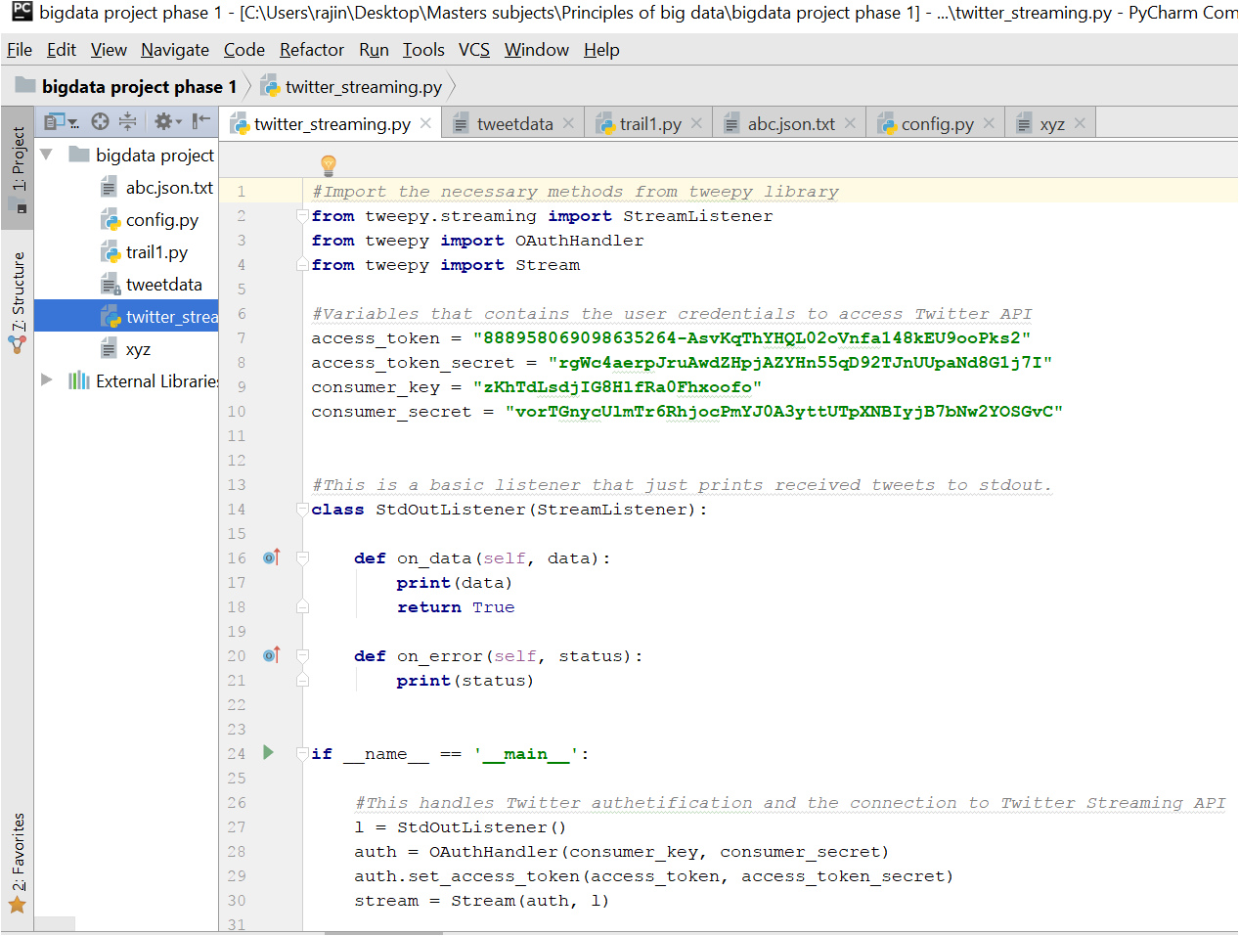

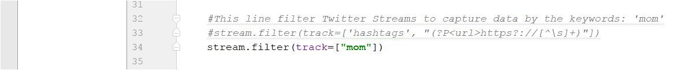

**Output Screenshot: Collected Tweets:**

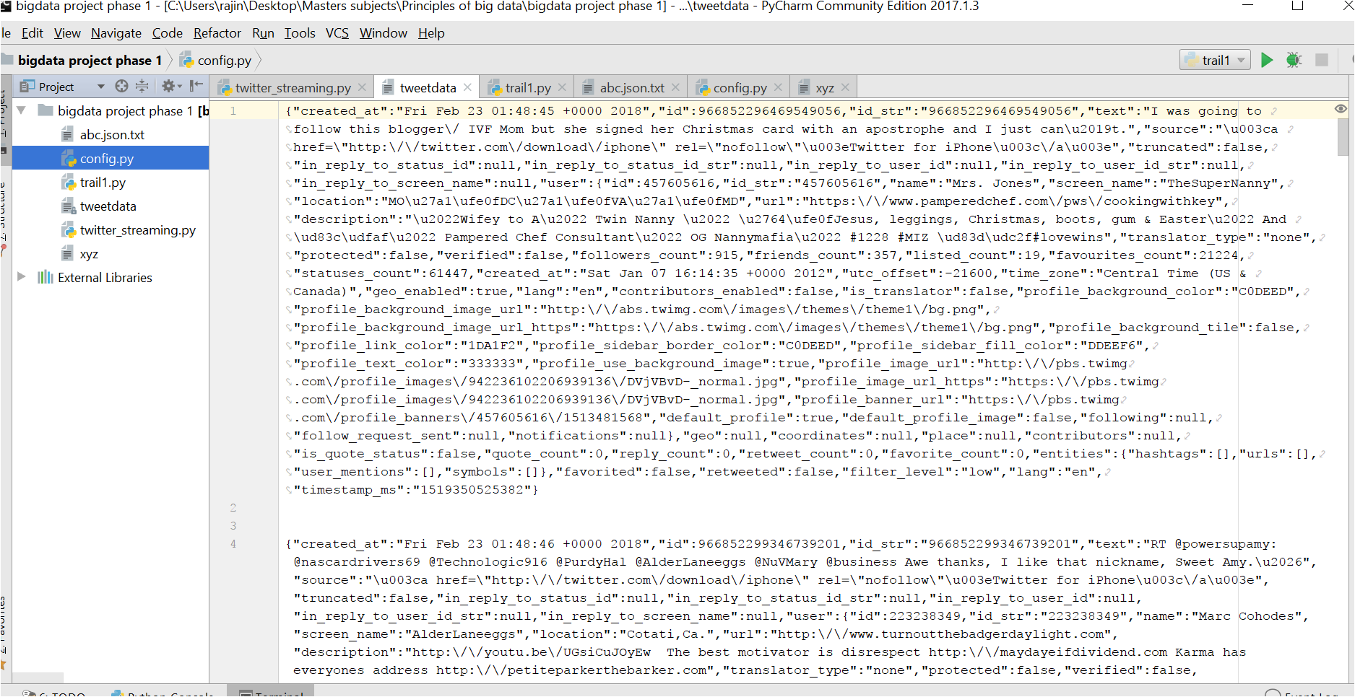

***Step 2: Extraction of URLs and hashtags from collected tweets:***

**Code:**

**import codecs**

**from datetime import datetime**

**import json**

**import os**

**import string**

**import sys**

**import time**

**def parse_json_tweet(line):**

**tweet = json.loads(line)**

***# print line***

**if tweet['lang'] != 'en':**

***# print "non-english tweet:", tweet['lang'], tweet***

**return ['', '', '', [], [], []]**

**date = tweet['created_at']**

**id = tweet['id']**

**nfollowers = tweet['user']['followers_count']**

**nfriends = tweet['user']['friends_count']**

**if 'retweeted_status' in tweet:**

**text = tweet['retweeted_status']['text']**

**else:**

**text = tweet['text']**

**hashtags = [hashtag['text'] for hashtag in tweet['entities']['hashtags']]**

**users = [user_mention['screen_name'] for user_mention in tweet['entities']['user_mentions']]**

**urls = [url['expanded_url'] for url in tweet['entities']['urls']]**

**media_urls = []**

**if 'media' in tweet['entities']:**

**media_urls = [media['media_url'] for media in tweet['entities']['media']]**

**return [hashtags, urls]**

**'''start main'''**

**if __name__ == "__main__":**

**file_timeordered_json_tweets = codecs.open(sys.argv[1], 'r', 'utf-8')**

**fout = codecs.open(sys.argv[2], 'w', 'utf-8')**

***# efficient line-by-line read of big files***

**for line in file_timeordered_json_tweets:**

**try:**

**[tweet_gmttime, tweet_id, text, hashtags, users, urls, media_urls, nfollowers, nfriends] = parse_json_tweet(**

**line)**

***# if not tweet_gmttime: continue***

***# fout.write(line)***

***# "created_at":"Mon Feb 17 14:14:44 +0000 2014"***

**try:**

**c = time.strptime(tweet_gmttime.replace("+0000", ''), '%a %b %d %H:%M:%S %Y')**

**except:**

**print("pb with tweet_gmttime", tweet_gmttime, line)**

**pass**

**tweet_unixtime = int(time.mktime(c))**

***# fout.write(line)***

**fout.write(str(**

**[tweet_unixtime, tweet_gmttime, tweet_id, text, hashtags, users, urls, media_urls, nfollowers,**

**nfriends]) + "\n")**

**except:**

***# print "pb with tweet:", line***

***# print sys.exc_info()[0], line***

**pass**

**file_timeordered_json_tweets.close()**

**fout.close()**

**Code Screenshots :**

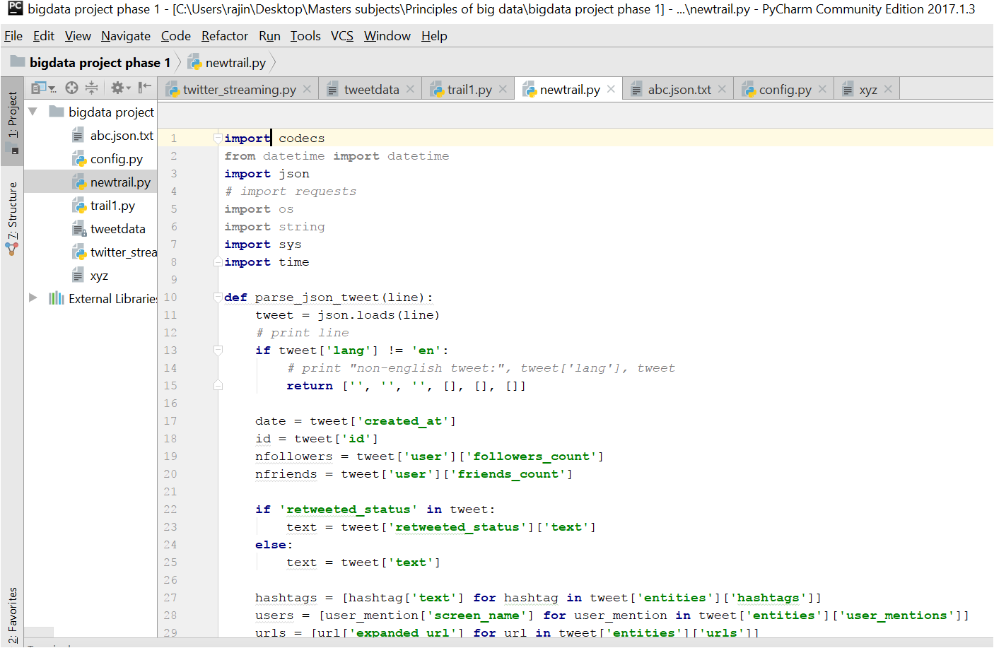

**Output Screenshot: Extracted URLs and Hashtags:**

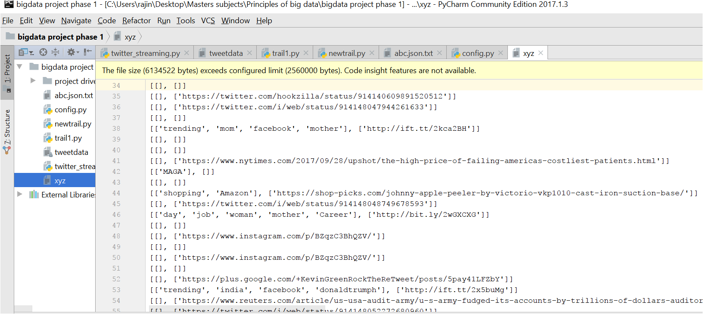

***Step 3: Running Word Count Program in Hadoop:***

**Screenshots of commands executed while running word count program:**

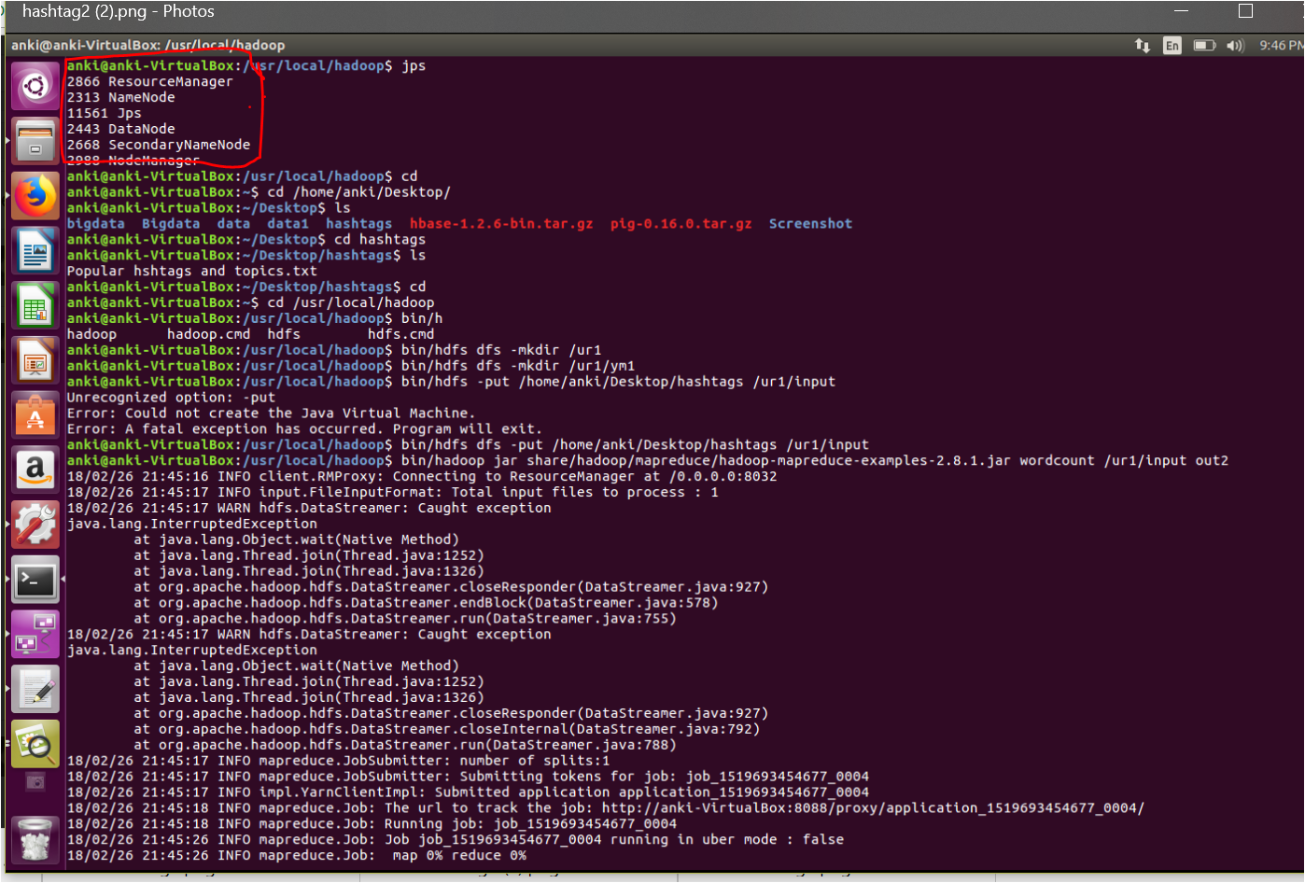

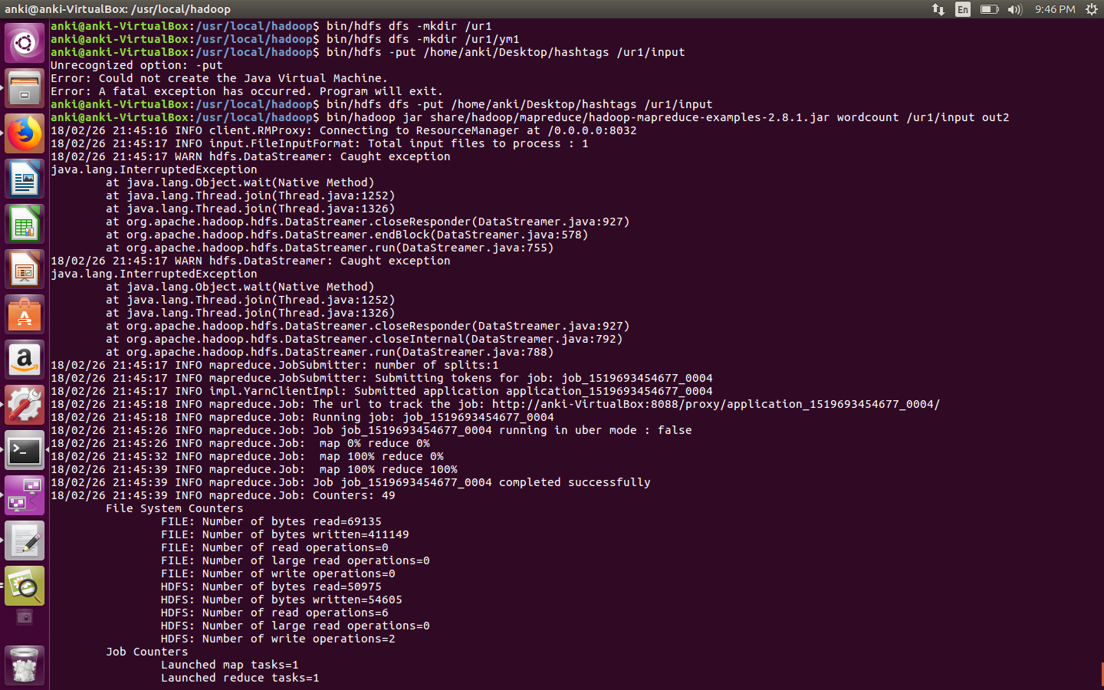

**Word Count of URLs:**

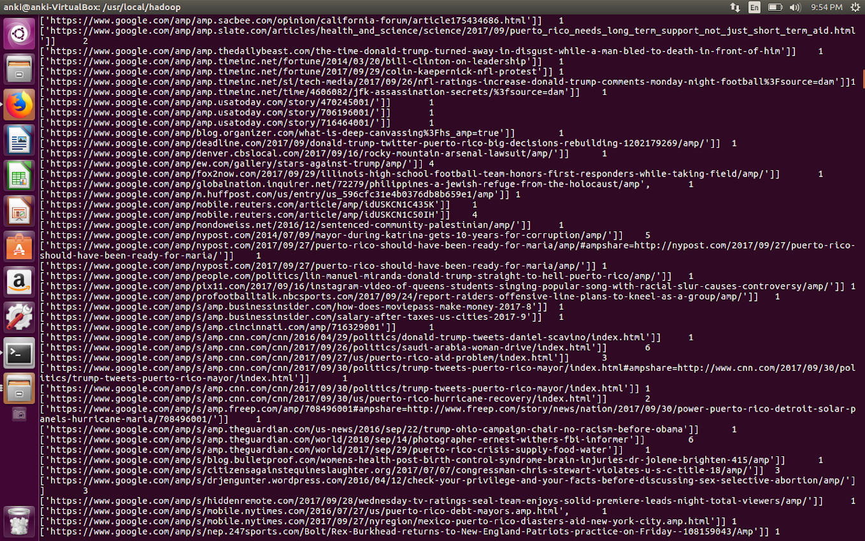

**Word Count of HashTags:**

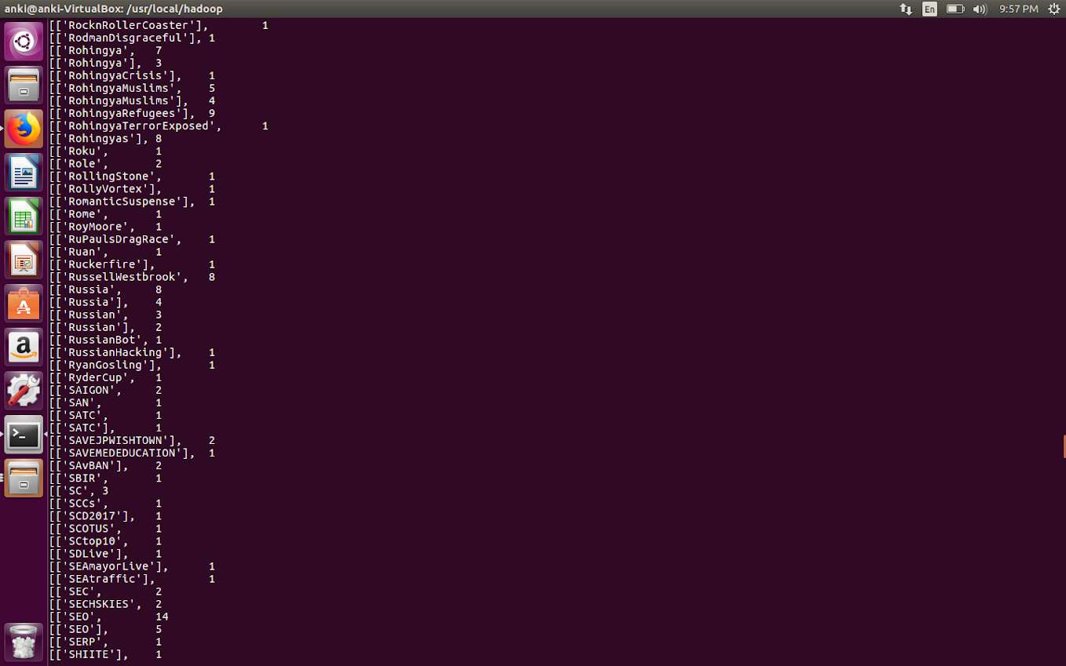

**HDFS Screenshot :**

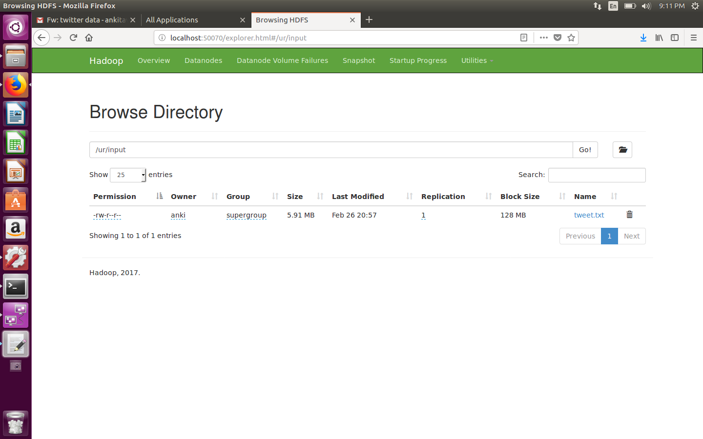

**Screenshot of log files created:**

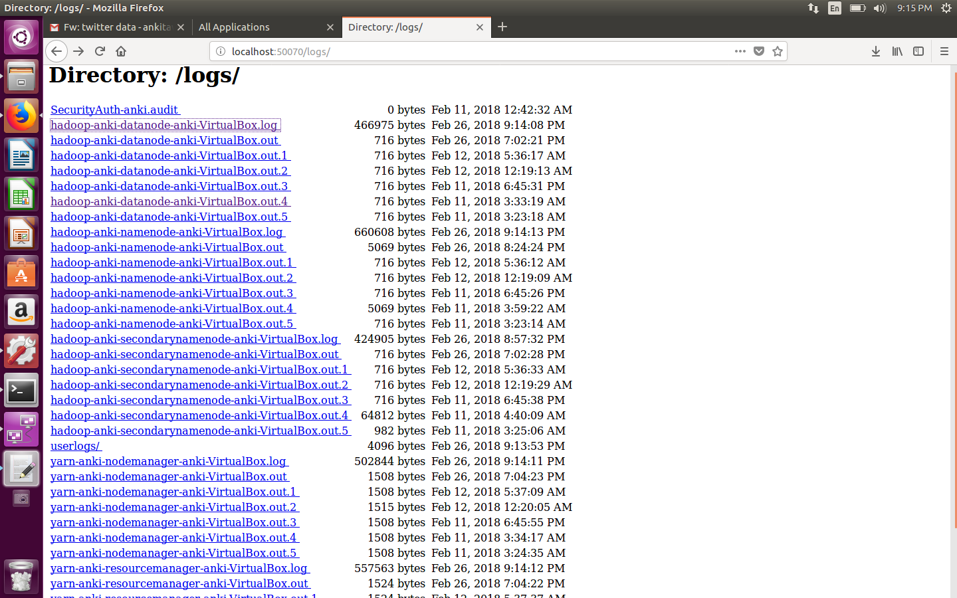

***Step 4: Running Word Count Program in Apache Spark:***

**Screenshots of commands executed while running word count program:**

1.Starting Spark: using bin/spark-shell command:

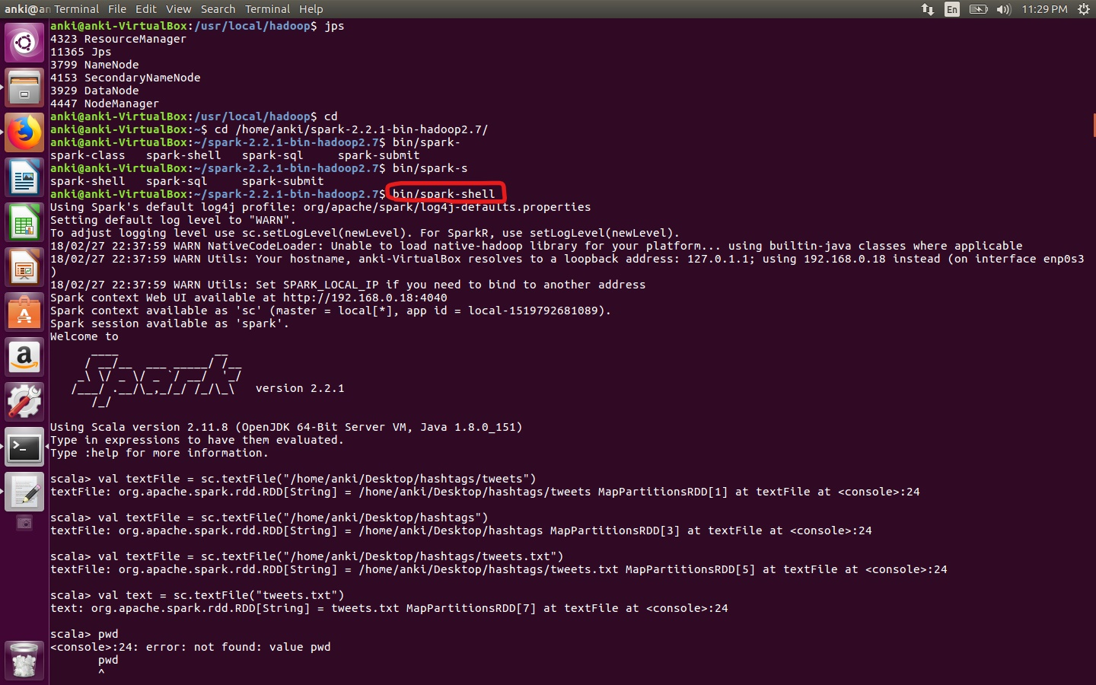

2. Loading the data:

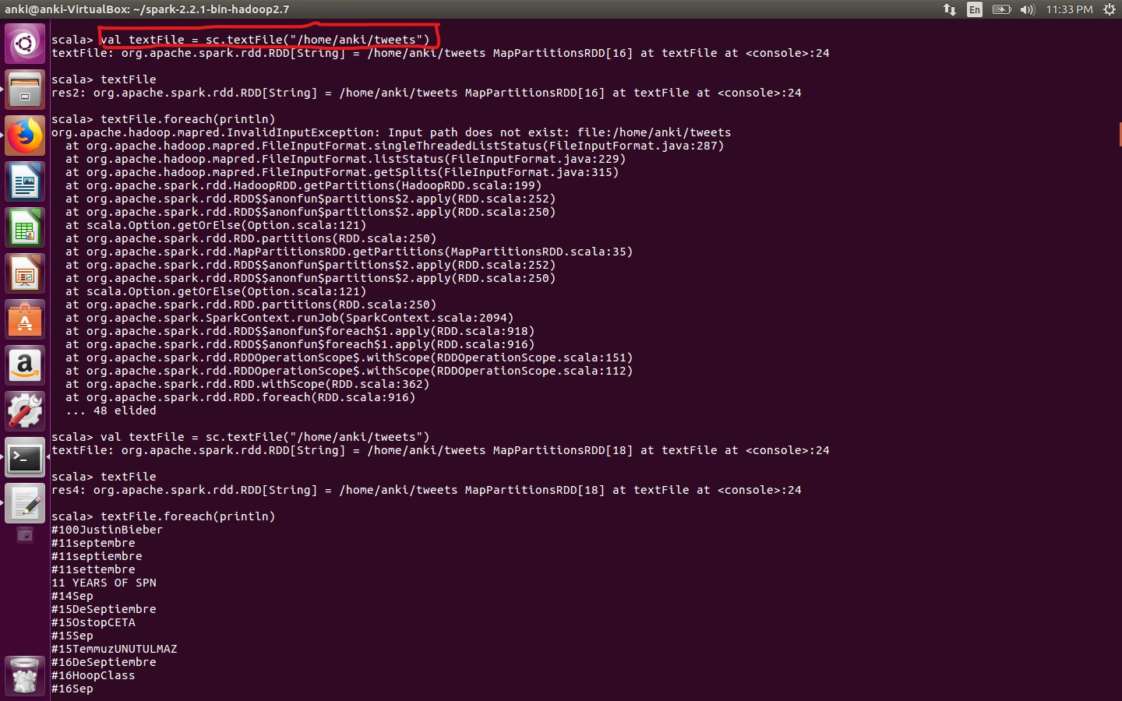

3. Splitting content in our file as strings and applying map and reduce functions to perform word count, using the below highlighted command:

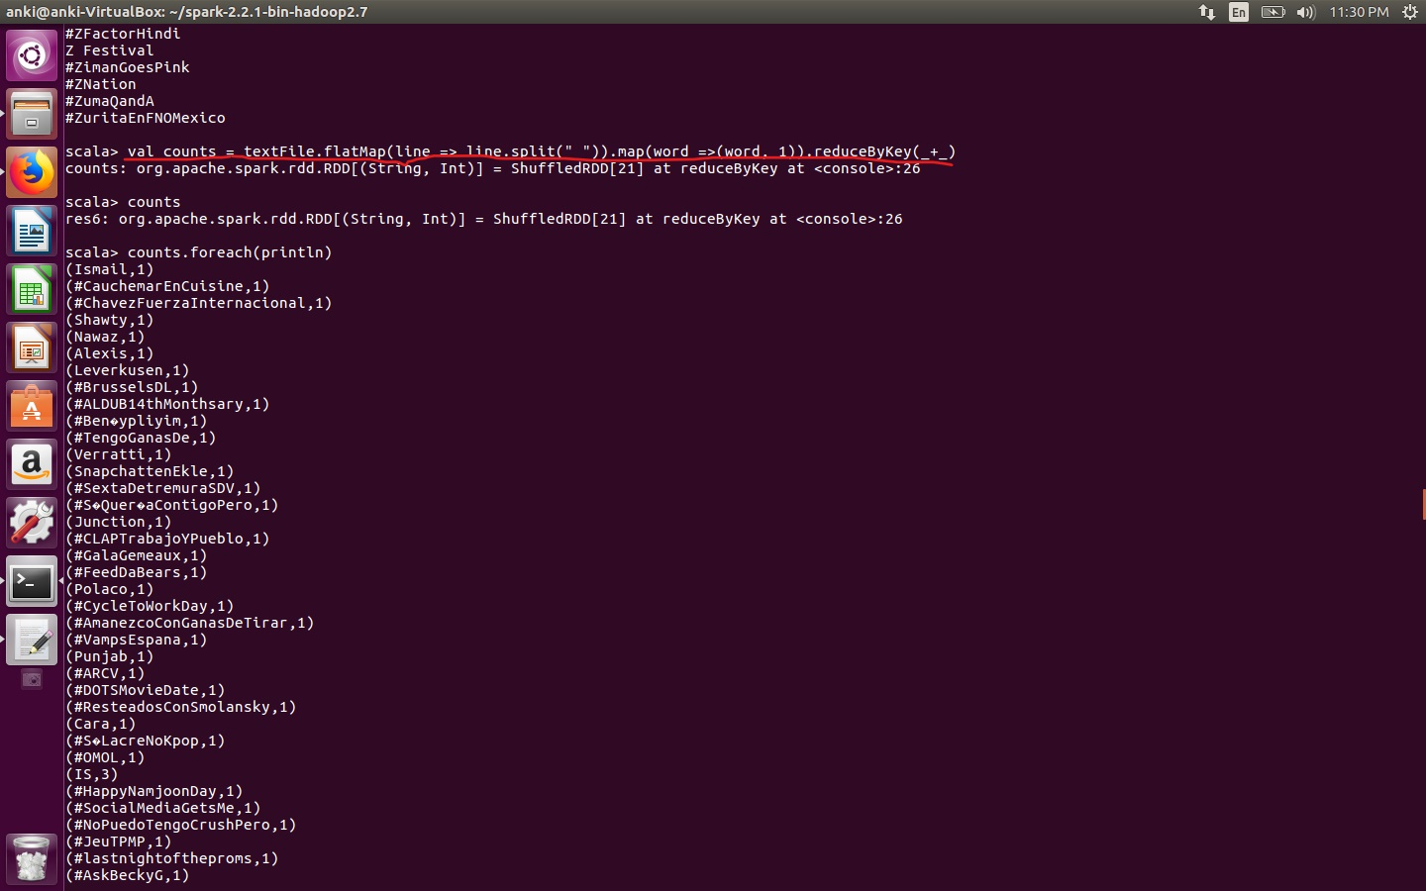

4. Finally collecting output which displays the word count in the form of an array of key value pairs:

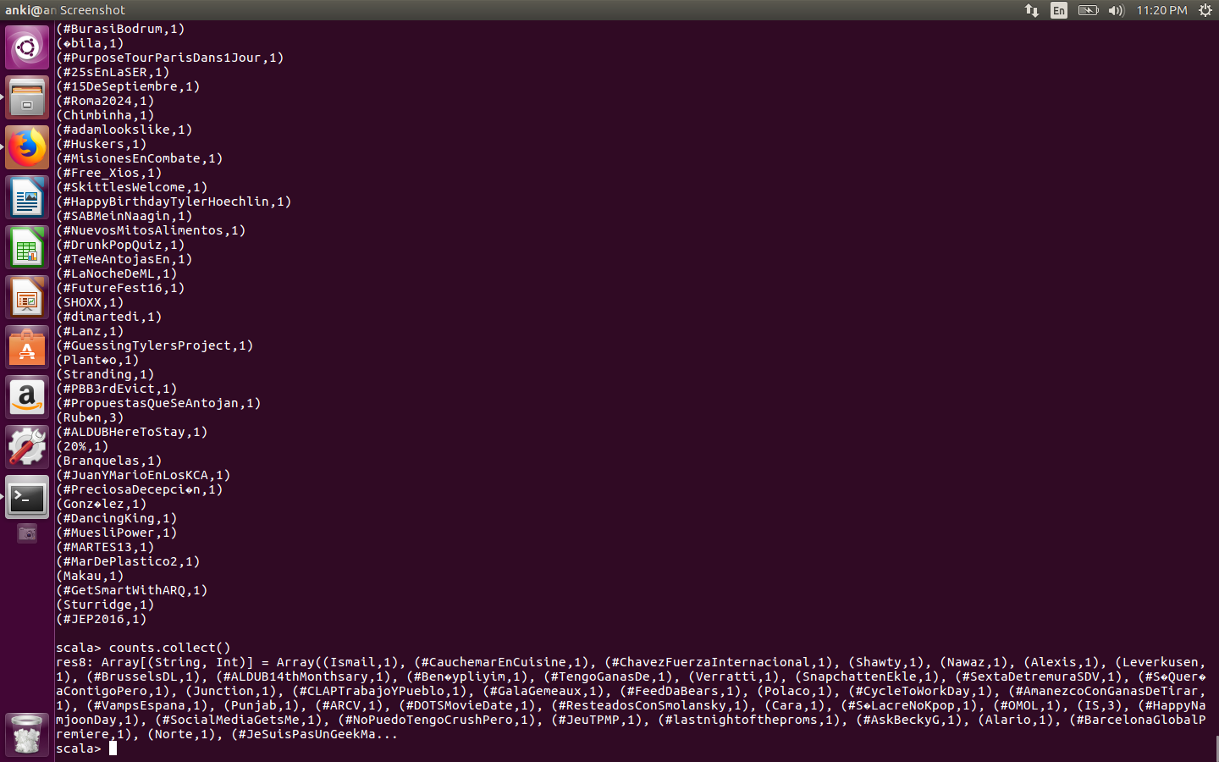

***References:***

<http://adilmoujahid.com/posts/2014/07/twitter-analytics/>

<https://github.com/heerme/twitter-topics/blob/master/extract-json-to-text-stream.py>

https://www.youtube.com/watch?v=YZnNb0BTrS4&list=PLJNKKS4iwuamrvNVahopRziurK7XNCc5B&index=3